Description:

The entity generates a trigger and data signals according the chosen scene, the user chose one of different scenes that are defined in the entity (we have 5 scenes for now).

The internal output data is a cyclic counter that change from 0 to (2^ num_of_signals_g) – 1, but we can also get the data and trigger signals from an external source.

Generic table

|  |  |  |
| --- | --- | --- |
| Name | Width | Description |
| reset_polarity_g | 1 | '1' reset active high, '0' active low |
| enable_polarity_g | 1 | '1' the entity is active high, '0' entity is active low |
| data_width_g | 8 | defines the width of the data lines of the system |
| num_of_signals_g | 4 | number of signals that will be recorded simultaneously |
| external_en_g | 1 | 1 -> getting the data from an external source . 0 -> dout is a counter |
| Add_width_g | 8 | width of address word in the WB |
| len_d_g | 1 | Length Depth |
| type_d_g | 1 | Type Depth |

Signals table

|  |  |  |  |
| --- | --- | --- | --- |
| Name | Direction | Width | Description |
| clk | In | 1 | System clock |
| Reset | In | 1 | System reset |
| data_in | In | 1 | External data in |
| trigger_in | In | num_of_signals_g | External trigger in |
| ADR_I | In | Add_width_g | contains the address word |
| DAT_I | In | data_width_g | contains the data in word |
| WE_I | In | 1 | '1' for write, '0' for read |
| STB_I | In | 1 | '1' for active bus operation, '0' for no bus operation |
| CYC_I | In | 1 | '1' for bus transition request, '0' for no bus transition request |
| TGA_I | In | (data_width_g)*(type_d_g) | contains the type word |
| TGD_I | In | (data_width_g)*(len_d_g) | contains the len word |
| reg_data | In | data_width_g | data to be transmitted to the WM |
| reg_data_valid | In | 1 | data to be transmitted to the WM validity |
| stall | In | 1 | stall - suspend wishbone transaction |
| data_out | Out | num_of_signals_g | Output data |
| trigger_out | Out | 1 | Output trigger |
| ACK_O | Out | 1 | '1' when valid data is transmitted to MW or for successful write operation |
| DAT_O | Out | data_width_g | data transmit to MW |
| STALL_O | Out | 1 | STALL - WS is not available for transaction |
| typ | Out | (data_width_g)*(type_d_g) | Type |
| len | Out | (data_width_g)*(len_d_g) | Length |
| active_cycle | Out | 1 | CYC_I outputted to user side |

Signal generator state machine

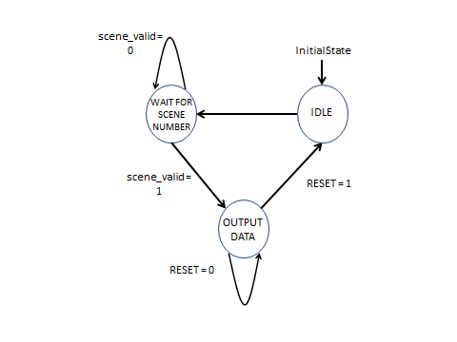

Output table

